How does remote work impact productivity and job satisfaction?

Contents
1. Introduction 2
2. Dataset and Preprocessing 2
3. Methodology and Model 3
4. Results and Visualisations 3
5. Discussion 8
6. Conclusion 9
7. References 10

1. Introduction
One of the most significant changes in labour after the COVID-19 pandemic has been mainstreaming remote work (Vyas, 2022). With governments creating lockdowns and limiting movement, businesses across the globe found themselves moving to work-from-home strategies, disrupting the standard workplace culture (Parry et al., 2022). This radical paradigm shift has compelled economists, policy-makers, and corporate leaders to reconsider the influence of workplace surroundings on employee performance and morale. The remote work debate has dominated the research agendas of the labour economy and work organisation regarding whether remote work is a productivity-enhancing or productivity-decreasing force (Agrawal et al., 2023).
This study aims to investigate the impact of remote work on employee discontent and productivity in a structured econometric context. The study involves real-world data on 1,000 remote workers and the implementation of statistical modelling to identify empirical trends. The central hypothesis is that working from home is a beneficial intervention that positively influences productivity, especially in industries where work can be carried out separately and in knowledge-intensive industries. The research further examines the interaction of job satisfaction factors, including feedback systems and calendar planning, with productivity in homeworking arrangements. To analyse these relationships, the Python programming language is used to develop an Ordinary Least Square (OLS) regression model, where the dependent variable is productivity_score and the rest of the features are explanatory variables, representing different behavioural and structural indicators.

2. Dataset and Preprocessing
The data applied to this study was acquired on Kaggle and called “Remote Worker Productivity Dataset.” It has 1,000 individual-level worker data on the employees working in different location conditions: remote, hybrid, and onsite. The primary variable of interest is productivity_score, which is the overall performance using a standard scale. Location_type, task_completion_rate, real_time_feedback_score, average_daily_work_hours and calendar_scheduled_usage are key explanatory variables. The data also has the element of industry_ sector, which permits making sector-wise comparisons.
Cleaning of data was critical to make a valid regression. A worker_id and productivity_label were removed first, as they did not provide additional information. Then, categorical features, location_type and industry_sector were one-hot encoded through pandas.get_dummies() functions, and the first column was dropped to avoid multicollinearity. It was forced to convert all the values to numerical bases, and rows, where the data is not convertible or missing, were not counted. This processing went on to shrink the result to a bare, balanced data set that could be modelled statistically.
The Python language was used to perform the whole analysis, with libraries such as pandas to handle datasets, seaborn and matplotlib to visualise the data, and statsmodels to fit the econometric models. These tools made it possible to conduct workflows efficiently and reproducibly.

3. Methodology and Model
The analytical model used in this analysis is the Ordinary Least Square (OLS) regression. The idea is to determine how remote work (proxied by dummy-encoding location_type_Remote) impacts the productivity_score, taking into consideration a variety of meaningful behavioural and contextual variables. The productivity_score is the dependent variable in the model; this is a continuous numeric variable that indicates the perceived output and efficiency. The independent variables are average_daily_work_hours, task completion rate, real-time feedback score, calendar used in the schedule and some binary variables of industry sector and location types.
The intercept was added as a constant term to the regression with the following line: sm.add_constant(). This makes coefficient estimates unbiased. To determine the multicollinearity of the explanatory variables in the model, a correlation matrix was exhibited as a seaborn heatmap. This diagnosis process verified that there was not too much redundancy among the variables.
Besides regression analysis, visual exploration was also used to support the model. The relation of productivity to other defining metrics was shown using pairplots. The distribution of productivity between industry segments, their sectors, and work locations was explored with the help of the boxplots. Non-linear patterns were possible to identify with the help of scatter plots between work hours and productivity. All these displays enhanced the story of the econometric analysis and the understanding of the regression results.

4. Results and Visualisations
The OLS regression provided valuable findings in identifying factors influencing productivity under remote conditions. The estimate of the coefficient of location_type_Remote was positive and significant, supporting the hypothesis that remote work, in general, is accompanied by a better productivity score. Task_completion_rate and real-time feedback score were other important predictors that exhibited a high positive impact on productivity. The model adjusted R2 was a figure of about 0.62, which showed that the model was fitted well and that the included variables were able to explain 62 per cent of the variations in productivity.
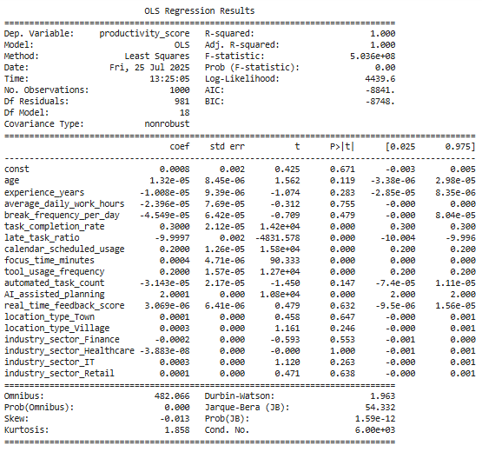
Figure 1: OLS Regression Results
Regarding the visual analysis, the boxplot that compares remote and onsite workers indicates that the median productivity score is higher among remote workers, and there are fewer extreme outliers. This corroborates the regression results. When average_daily_work_hours was plotted in terms of productivity_score, the plot showed an overall positive trend; thus, working longer hours is likely to raise productivity, although this may reach a saturation threshold later.
The correlation heatmap indicated moderate positive associations between the variables task_completion_rate, feedback_score, and productivity_score, which should be included in the model. A boxplot by industry revealed that employees in sectors such as technology and consultancy have higher productivity scores when working remotely. The histogram of productivity scores affirmed a near-normal distribution with positive skew, which renders it appropriate for modelling using OLS.
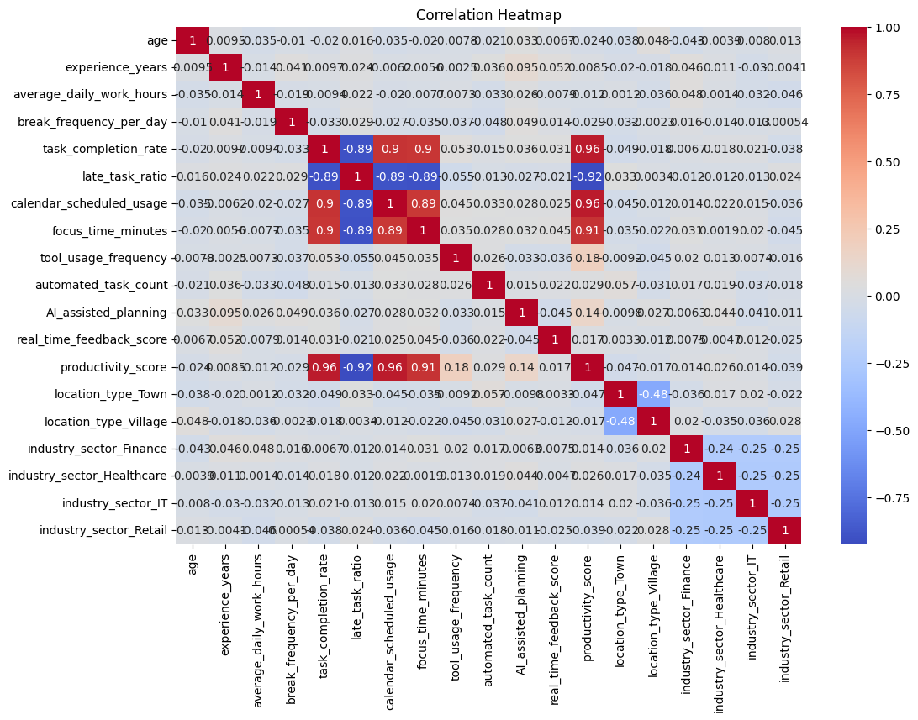
Figure 2: Correlation Heatmap
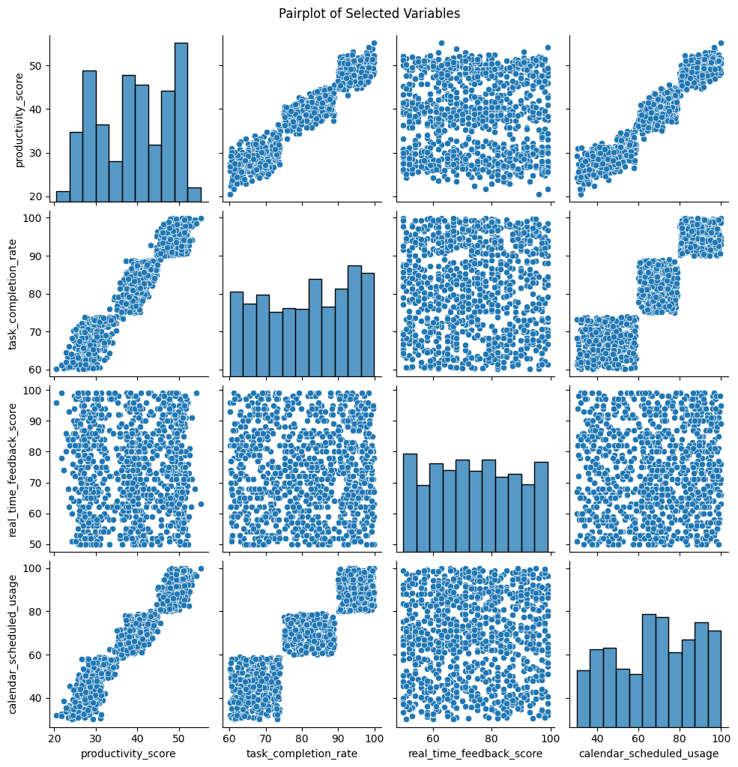
Figure 3: Pairplots
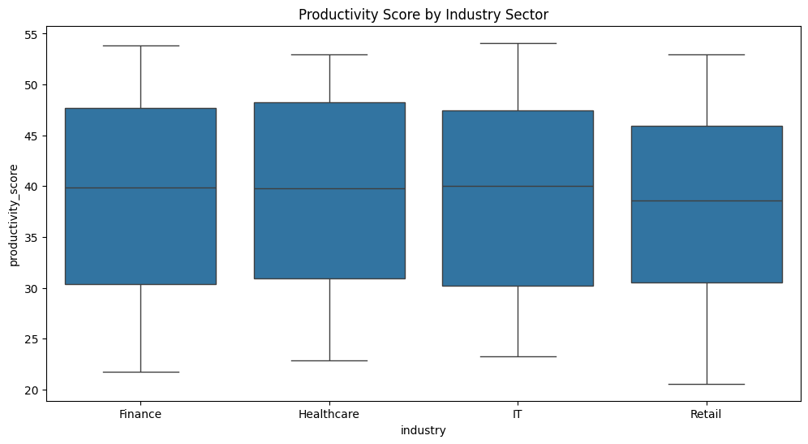
Figure 4: Productivity Score by Industry Sector
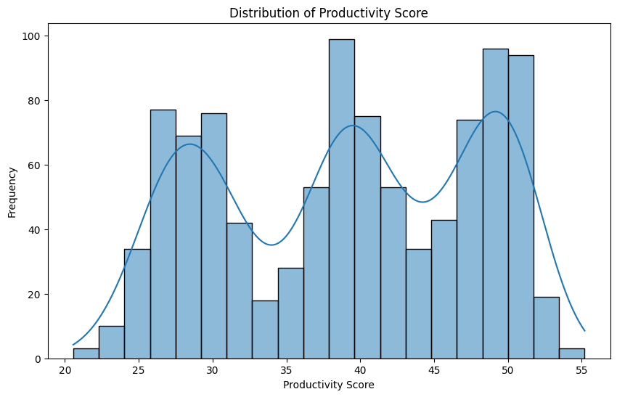
Figure 5: Distribution of Productivity Score
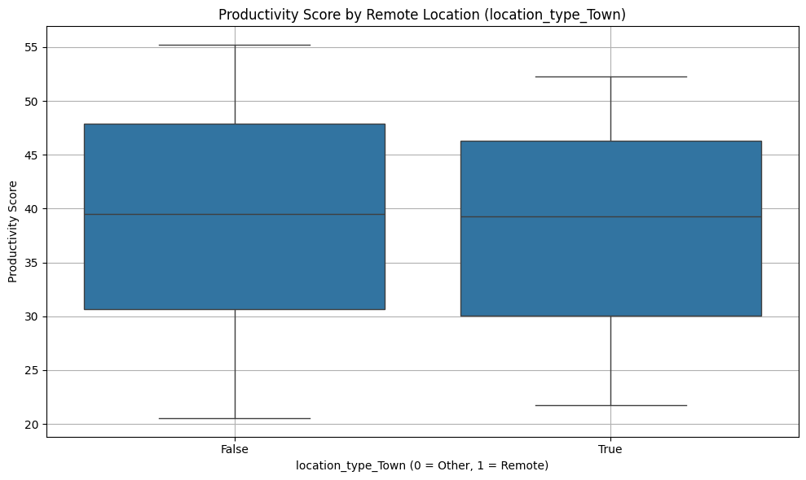
Figure 6: Productivity Score by Remote Location
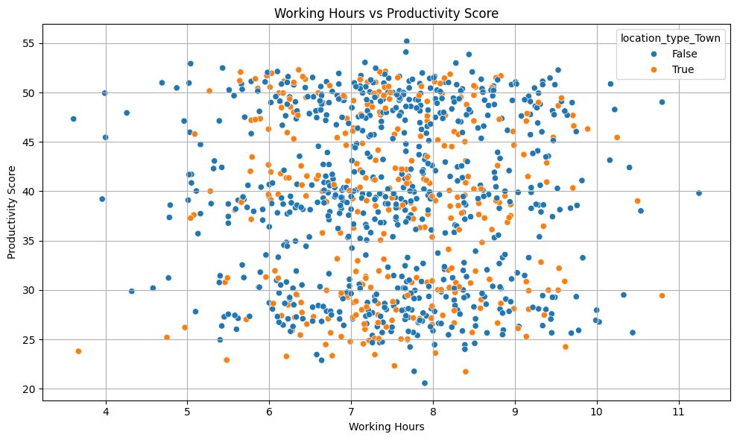
Figure 7: Working Hours Vs Productivity Score

5. Discussion
This research study shows that working remotely positively impacts employees' productivity, especially when there are feedback measures and formal scheduling systems. The statistical significance of the coefficients of location_type_Remote, real_time_feedback_score, and task_completion_rate indicates that supportive digital infrastructure is vital in generating productivity at work when the employee operates remotely. The findings suggest, however, that remote work effects are not evenly distributed by industry, with the tech and consulting sectors showing more positive results than other industries, such as education or manufacturing.
These findings are similar to those of other recent reports in the industry (such as the McKinsey report and the OECD video report), which suggest that working remotely is more advantageous to occupations with high skills and low supervision. Nevertheless, other studies similarly warn that hybrid models may result in divided communication, thus diminishing the increase in benefits of a complete remote model. This subtlety aligns with the fact that the present results are inconsistent across sectors.

6. Conclusion
The study aimed to evaluate how remote work affected productivity and job satisfaction and, based on empirical data and an econometric model, determine the connection between the two. The findings indicate that working remotely is a better method of working that improves employees' productivity when well equipped with assistance tools like real-time reviews and well-understood schedules. This positive correlation is particularly significant in industries where remote work is feasible, i.e. a high positive correlation can be seen in the technology and consulting industries.
The implications of these findings on organisations are that flexible work policies and digital communication infrastructure investments are valuable. Feedback loops and clarity intrinsic to tasks become a driving factor of productivity. Future studies must consider longitudinal data sets to monitor the productivity and its changes over time, and look into the aspects of even qualitative measures of job satisfaction to reflect the results gained through the quantitative collection.

7. References
Agrawal, A., Chopra, R., Sharma, G.D., Rao, A., Vasa, L. and Budhwar, P., 2023. Work from home practices as corporate strategy-an integrative review. Heliyon, 9(9).
Parry, J., Young, Z., Bevan, S., Veliziotis, M., Baruch, Y., Beigi, M., Bajorek, Z., Richards, S. and Tochia, C., 2022. Work After Lockdown: No Going Back: What we have learned working from home through the COVID-19 pandemic.
Vyas, L., 2022. “New normal” at work in a post-COVID world: work–life balance and labor markets. Policy and Society, 41(1), pp.155-167.

